**Number 01**

#include <stdio.h>

double

getPoints(double mark){

double point = 0;

if(mark>=90 && mark<=100){

point=4;

}else if(mark>=85 && mark<=89.99){

point=3.75;

}else if(mark>=80 && mark<=84.99){

point=3.5;

}else if(mark>=75 && mark<=79.99){

point=3.25;

}else if(mark>=70 && mark<=74.99){

point=3;

}else if(mark>=65 && mark<=69.99){

point=2.75;

}else if(mark>=60 && mark<=64.99){

point=2.5;

}else if(mark>=50 && mark<=59.99){

point=2.0;

}else{

printf("Error\n");

}

return point;

}

int main(){

printf("CGPA.\n");

int numofSub = 0;

double cgpa = 0;

double totalCredits = 0;

double totalPoints = 0;

printf("Enter the total nubmer of subjects: ");

scanf("%d",&numofSub);

double marks[numofSub], credits[numofSub];

for(int i=0; i<numofSub; i+=1){

printf("Enter marks of subject %d : ",i+1);

scanf("%lf",&marks[i]);

printf("Enter credits of subject %d : ",i+1);

scanf("%lf",&credits[i]);

totalCredits+=credits[i];

}

for(int i=0; i<numofSub; i+=1){

totalPoints += getPoints(marks[i])*credits[i];

}

cgpa = totalPoints/totalCredits;

printf("CGPA : %.2lf\n",cgpa);

return 0;

}

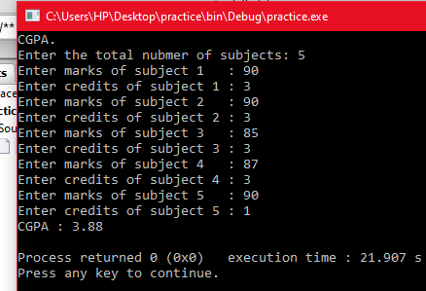

**Number 02**

#include <stdio.h>

double

getPoints(double mark){

double point = 0;

if(mark>=90 && mark<=100){

point=4;

}else if(mark>=85 && mark<=89.99){

point=3.75;

}else if(mark>=80 && mark<=84.99){

point=3.5;

}else if(mark>=75 && mark<=79.99){

point=3.25;

}else if(mark>=70 && mark<=74.99){

point=3;

}else if(mark>=65 && mark<=69.99){

point=2.75;

}else if(mark>=60 && mark<=64.99){

point=2.5;

}else if(mark>=50 && mark<=59.99){

point=2.00;

}else{

printf("Error\n");

}

return point;

}

int main(){

printf("CGPA of the student.\n");

int numofSub = 0;

double cgpa = 0;

double totalCredits = 0;

double totalPoints = 0;

printf("Enter the total nubmer of subjects: ");

scanf("%d",&numofSub);

double marks[numofSub], credits[numofSub];

for(int i=0; i<numofSub; i+=1){

printf("Enter marks of subject %d : ",i+1);

scanf("%lf",&marks[i]);

printf("Enter credits of subject %d : ",i+1);

scanf("%lf",&credits[i]);

totalCredits+=credits[i];

}

for(int i=0; i<numofSub; i+=1){

totalPoints += getPoints(marks[i])*credits[i];

}

cgpa = totalPoints/totalCredits;

printf("CGPA : %.2lf\n",cgpa);

return 0;

}

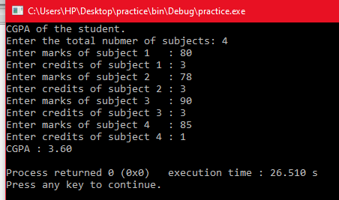

**Number 03**

#include<stdio.h>

void main()

{ int r1=5;

int r2=3;

int r3=9;

printf("r1= %d \n",r1);

printf("r2= %d\n",r2);

printf("r3= %d",r3);

}

void swap (int *r1,int *r2,int *r3)

{ int R;

R=*r1+*r2+*r3;

printf(" equivalent resistance R:");

}

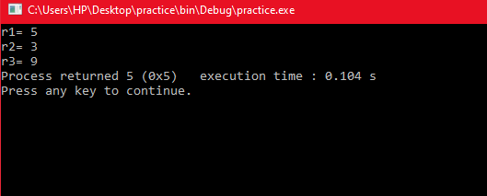

**Number 04**

#include<stdio.h>

void main()

{ int r1=4;

int r2=8;

int r3=1;

swap(r1,r2,r3);

} void swap

(int c,int d,int e)

{ printf("r1= %d \n",c);

printf("r2= %d \n",d);

printf("r3=%d \n",e);

int t;

int p;

t=c; c=d; d=t; p=e;p=d;

printf("r1= %d \n",c);

printf("r2= %d\n",d);

printf("r3=%d",e);

}

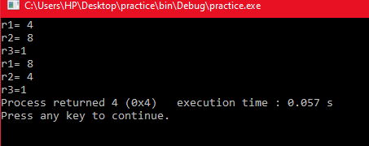

**Number 05**

#include<stdio.h>

void main() {

float swap(float,float,float);

float r1=5.5;

float r2=3.7;

float r3=9.8;

swap(r1,r2,r3); }

float swap(float c,float d,float e)

{ int Rs;

printf("r1= %f \n",c);

printf("r2= %f \n",d);

printf("r3= %f \n",e);

Rs=(c+d+e);

printf("equivalent resistance Rs");

return 0;

}

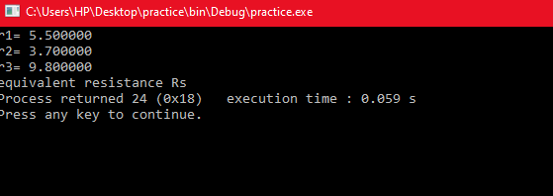

**Number 06**

#include <stdio.h>

double getPoints(double mark);

void calCgpa();

double getPoints(double mark){

double point = 0;

if(mark>=90 && mark<=100){

point=4;

}else if(mark>=85 && mark<=89.99){

point=3.75;

}else if(mark>=80 && mark<=84.99){

point=3.5;

}else if(mark>=75 && mark<=79.99){

point=3.25;

}else if(mark>=70 && mark<=74.99){

point=3;

}else if(mark>=65 && mark<=69.99){

point=2.75;

}else if(mark>=60 && mark<=64.99){

point=2.5;

}else if(mark>=50 && mark<=59.99){

point=2.00;

}else{

printf("Error\n");

}

return point;

}

void calCgpa(){

int numOfSub = 0;

double cgpa = 0;

double totalCredits = 0;

double totalPoints = 0;

printf("Enter the total nubmer of subjects: ");

scanf("%d",&numOfSub);

double marks[numOfSub], credits[numOfSub];

for(int i=0; i<numOfSub; i+=1){

printf("Enter marks of subject %d : ",i+1);

scanf("%lf",&marks[i]);

printf("Enter credits of subject %d : ",i+1);

scanf("%lf",&credits[i]);

totalCredits+=credits[i];

}

for(int i=0; i<numOfSub; i+=1){

totalPoints += getPoints(marks[i])*credits[i];

}

cgpa = totalPoints/totalCredits;

printf("CGPA : %.2lf\n",cgpa);

char chr;

printf("Calculate cgps? y=yes & n=no : ");

scanf(" %c",&chr);

if(chr=='y' || chr=='Y'){

calCgpa();

}

}

int main(){

printf("CGPA.\n");

calCgpa();

return 0;

}

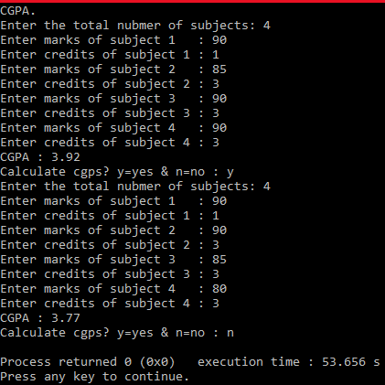

**Number 07**

#include<stdio.h>

void main()

{ swap(); }

void swap()

{ int a; int b;int c; int d; int e; int i;

for(i=0;i<=5;i++) {

printf("\n");

}

printf("Enter Number 1: ");

scanf("%d",&a);

printf("Enter Number 2: ");

scanf("%d",&b);

printf("Enter Number 3 : ");

scanf("%d",&c);

printf("Enter Number 4 : ");

scanf("%d",&d);

printf("Enter Number 5 : ");

scanf("%d",&e);

int sum;

sum=a+b+c+d+e;

int t ; sum=t;

printf("t=%sum\n",sum);

swap();

}

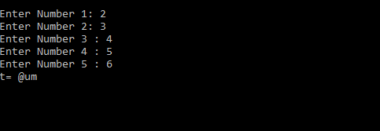

**LAB :8**

**Number 01**

#include<stdio.h>

#include<string.h>

void main()

{

char str1[]="R1=four ohm";

char str2[]="R2= four ohm";

int a,b;

a=strcmp(str1,"R1=four ohm");

b=strcmp(str1,str2);

printf("%d \n",a);

printf("%d",b);

}

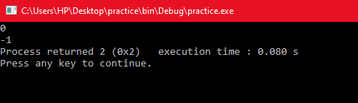

**Number 02**

#include<stdio.h>

#include<string.h>

char name[100];

int main()

{

char name[100];

printf("Enter full Name: \n");

gets(name);

strrev(name);

printf("reverse is:\n%s",name);

}

